Interpreter Design Pattern
Tuesday, June 30, 2020
3:36 PM
Intent
- You have multiple objectives that exist in a well-defined and well-understood domain.
- The objectives can be expressed with a simple language

Benefits
- The domain specific language provides a very compact representation for queries, commands or business rules in the given domain.
- The interpreter hides the complexity of the domain from the rest of the application architecture.

Disadvantages
- There is a risk that you're writing what appears to be an elegant and compact language expression, but that the low-level implementation of that expression is overly complex and does not perform well.

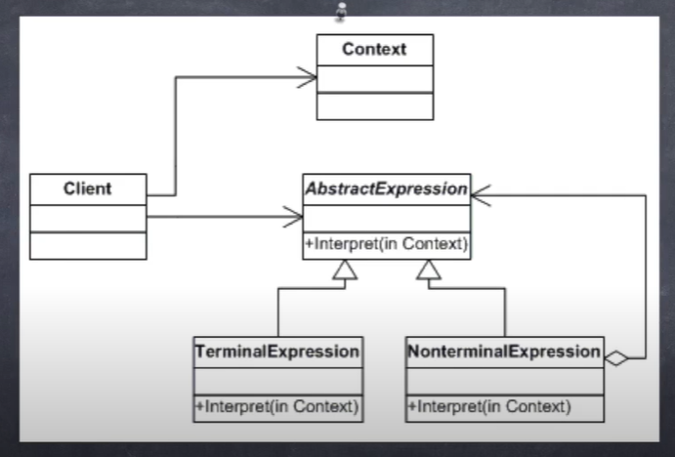

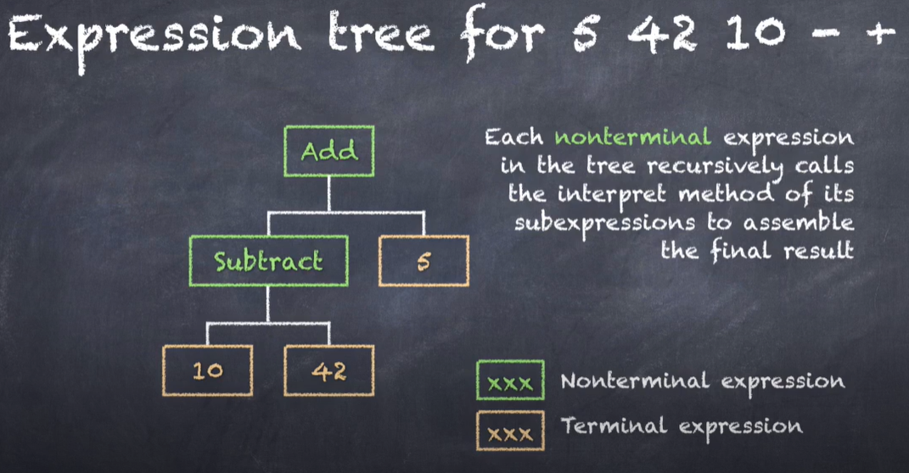

Checklist
- Decide if a Domain Specific Language offers a justifiable return on investment
- Define the grammar for the language
- Map each grammar rule to an expression class
- Organize the expression classes into a hierarchy
- Put global interpreter state in the Context class
- Optionally add a parser to build an expression tree from a language string
- Have the client use either the parse or pre-built expression trees to execute language commands

Final Comments
- If the interpreter has a very complex global state you can use the State pattern instead of a context object
- For very large expression trees you can use the Flyweight pattern to share terminal expressions

Interpreter Pattern
- Provides an interpreter for a domain-specific language
- You can add a parser to build the expression tree from a language string
- The pattern provides a very compact representation for queries, commands or business rules, but also masks the complexity of the problem domain from the rest of the application architecture.
- You can combine the Interpreter pattern with the state or flyweight patterns

Terminologies:
A domain-specific language (DSL) is a computer language specialized to a particular application domain. This is in contrast to a general-purpose language (GPL), which is broadly applicable across domains. There are a wide variety of DSLs, ranging from widely used languages for common domains, such as HTML for web pages, down to languages used by only one or a few pieces of software, such as MUSH soft code.

Compensation:
解释器模式：给定一个语言，定义它的文法的一种表示，并定义一个解释器，这个解释器使用该表示来解释语言中的句子。（传码——解码）

如果一种特定类型的问题发生的频率足够高，那么可能就值得将该问题的各个实例表述为一个简单语言中的句子。这样就可以构建一个解释器，该解释器通过解释这些句子来解决该问题。

解释器模式可以很容易改变和扩展文法，因为该模式使用类来表示文法规则，你可使用继承来改变或扩展该文法。也比较容易实现文法，因为抽象语法树种各个节点的类的实现大体类似，这些都易于直接编写。

Add: Define different operations according to different input. And each operation could be a class.
Afterwards, combine the operations in sequence to interpret the input.

